- Aim: Write a C program to simulate a Deterministic Finite Automata (DFA) for the given language representing strings that start with a and end with a
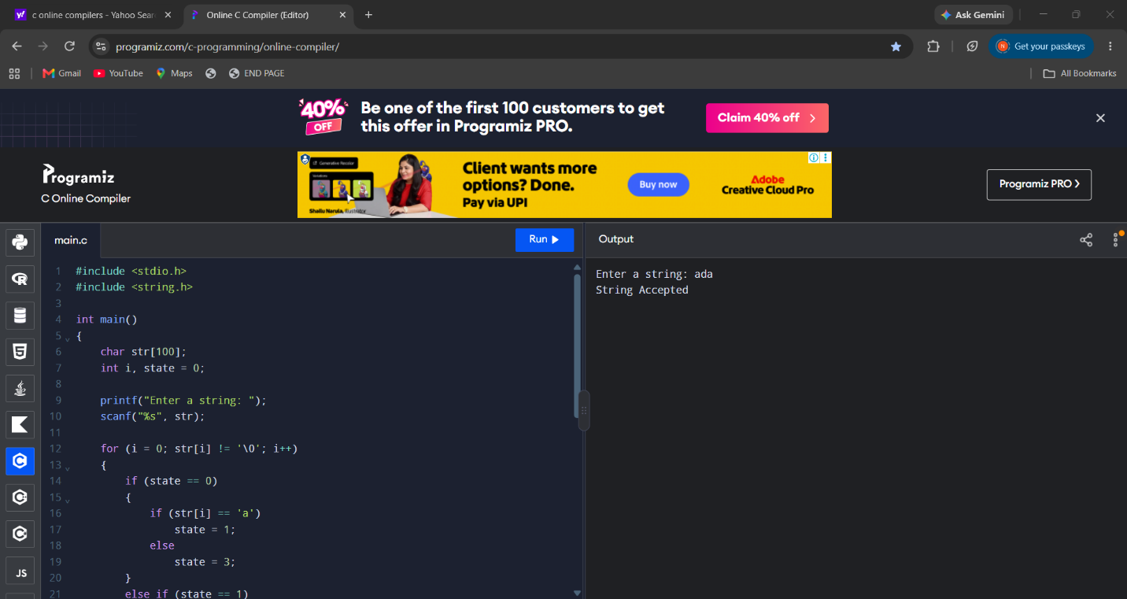
Result
The C program successfully simulates a DFA and accepts strings that start with a and end with a. Strings that do not satisfy both conditions are rejected.

- Aim: Write a C program to simulate a Deterministic Finite Automata (DFA) for the given language representing strings that start with 0 and end with 1
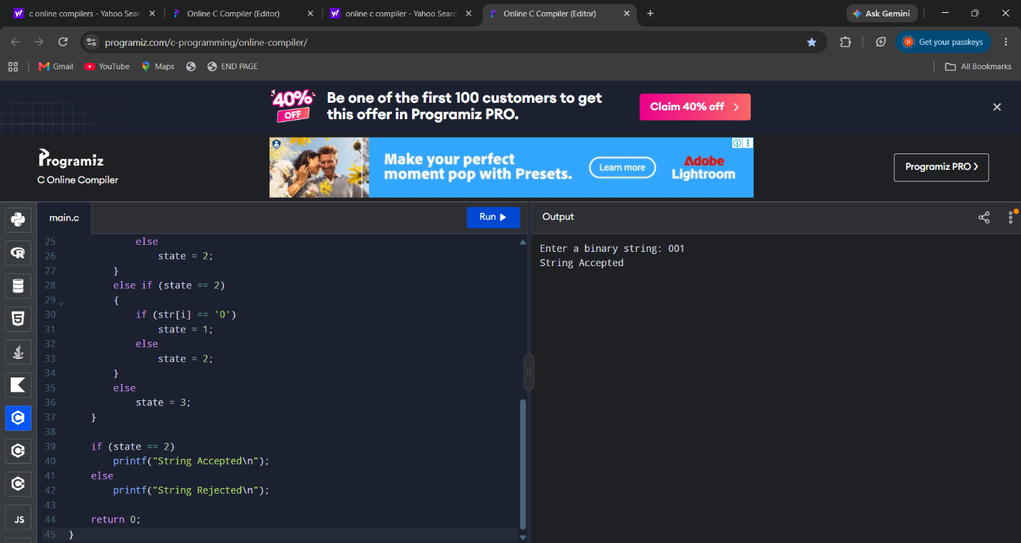
Result
The C program successfully simulates a DFA that accepts strings starting with 0 and ending with 1. All other strings are rejected.

- Aim: Write a C program to check whether a given string belongs to the language defined by a Context Free Grammar (CFG) S → 0A1 A → 0A | 1A | ε
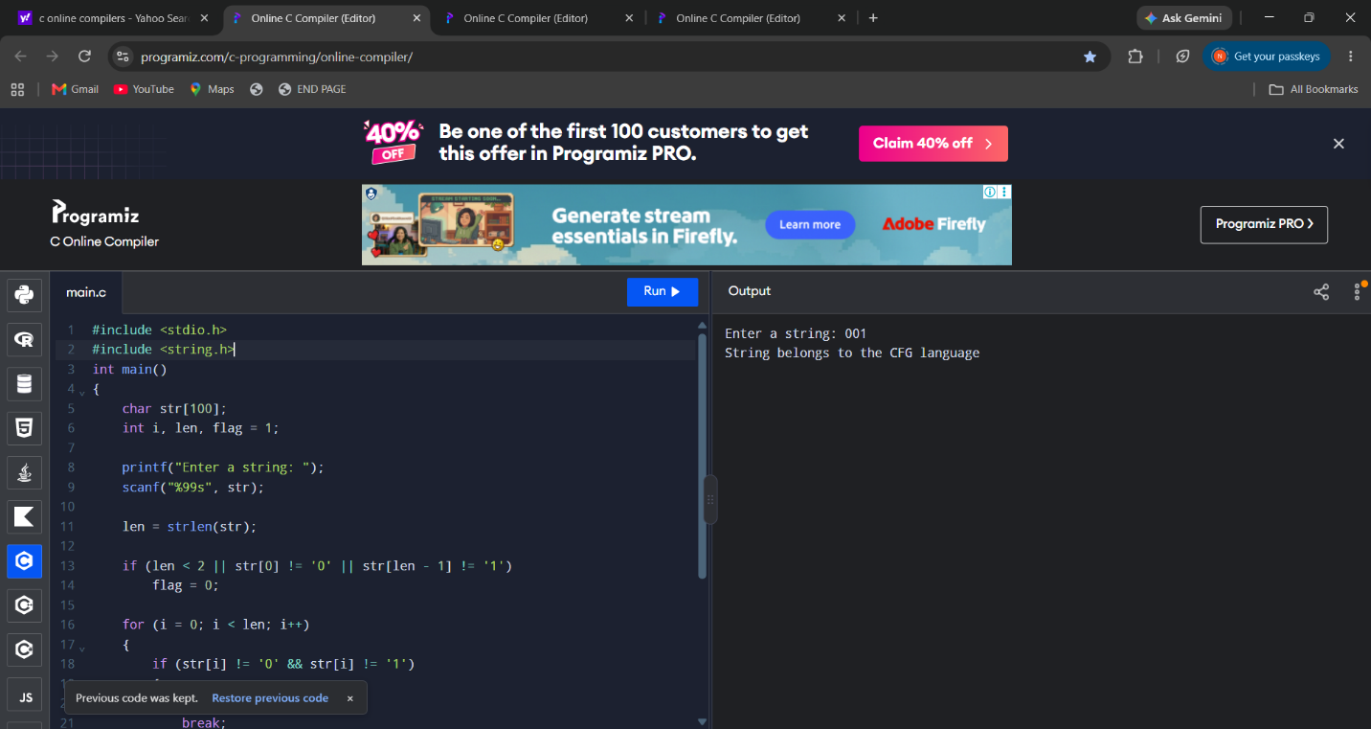
Result
The program checks whether the given string starts with 0 and ends with 1. If both conditions are satisfied and the string contains only 0s and 1s, it is accepted; otherwise, it is rejected.

- Aim: Write a C program to check whether a given string belongs to the language defined by a Context Free Grammar (CFG) S → 0S0 | 1S1 | 0 | 1 | ε
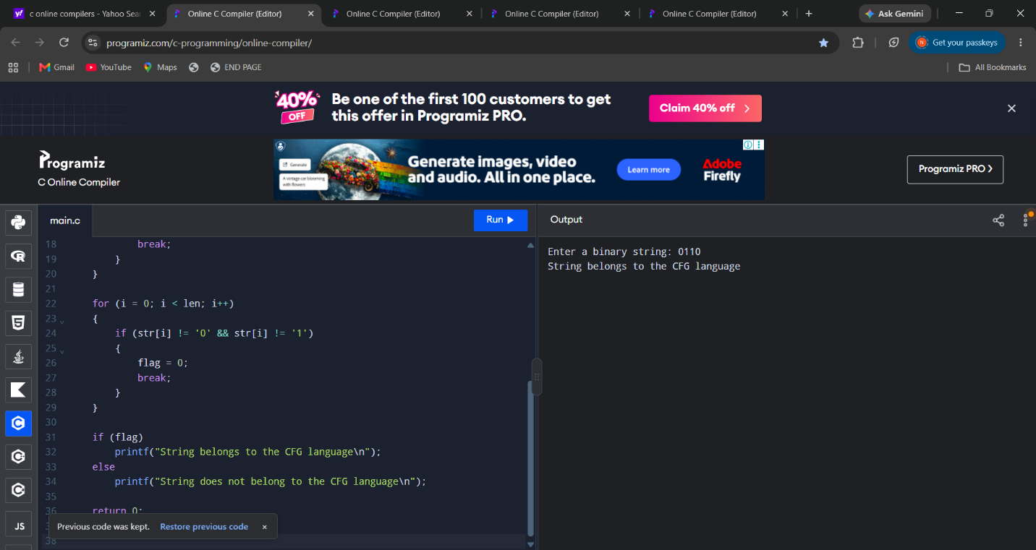
Result
The program successfully checks whether the given binary string is a palindrome. If the string reads the same forward and backward, it is accepted; otherwise, it is rejected.

- Aim: Write a C program to check whether a given string belongs to the language defined by a Context Free Grammar (CFG) S → 0S0 | A A → 1A | ε
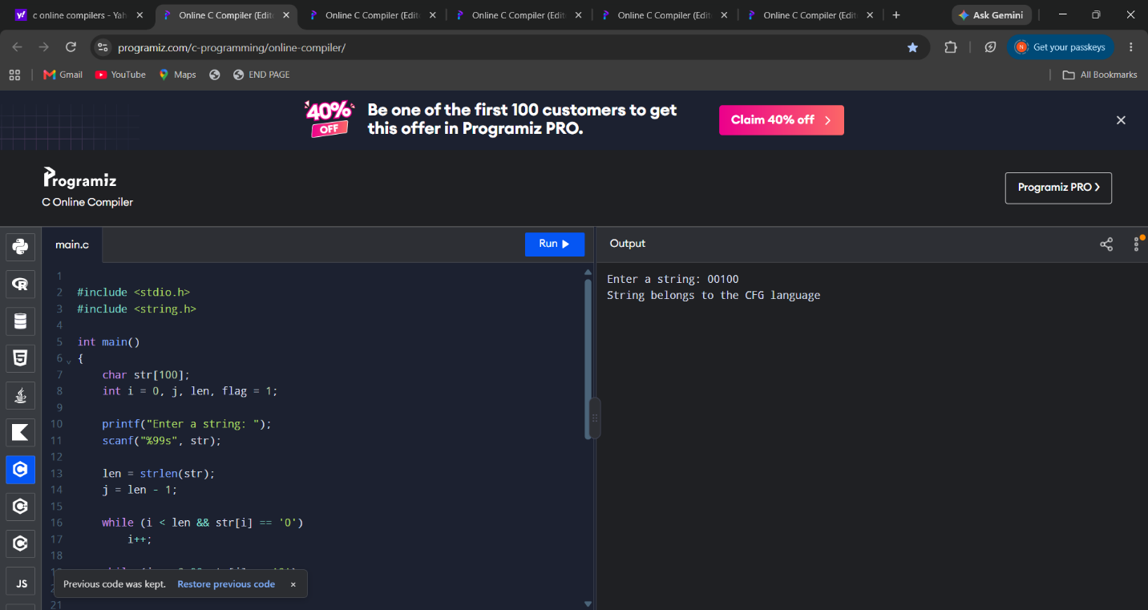
Result
The program checks whether the given string follows the pattern \(0^n1^m0^n\). If the number of leading and trailing zeros is equal and the middle contains only ones, the string is accepted; otherwise, it is rejected.

6.Aim: Write a C program to check whether a given string belongs to the language defined by a Context Free Grammar (CFG) S → 0S1 | ε
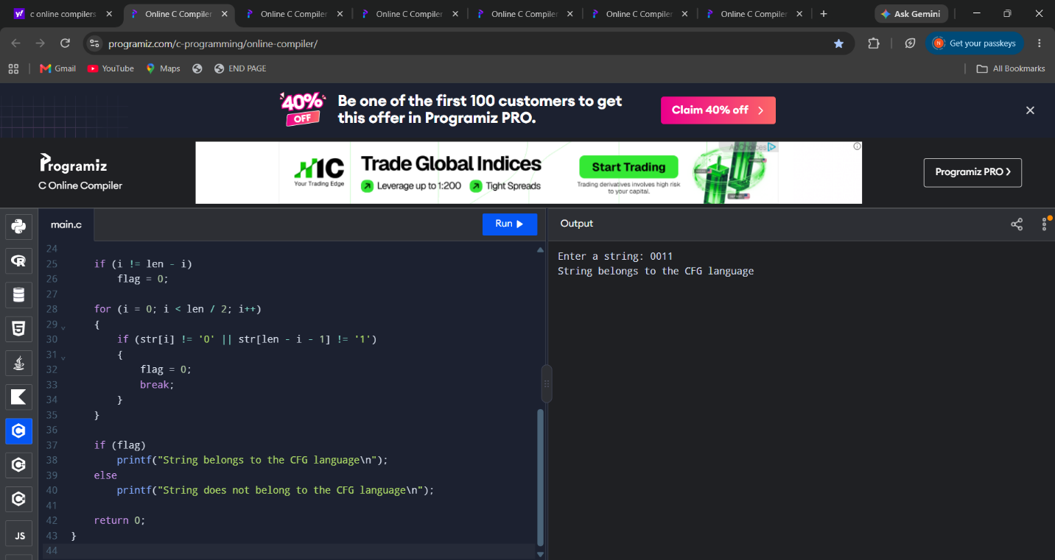
Result
The program checks whether the given string contains an equal number of 0s followed by an equal number of 1s. If the string matches the pattern \(0^n1^n\), it is accepted; otherwise, it is rejected.

7.Aim: Write a C program to check whether a given string belongs to the language defined by a Context Free Grammar (CFG) S → A101A, A → 0A | 1A | ε
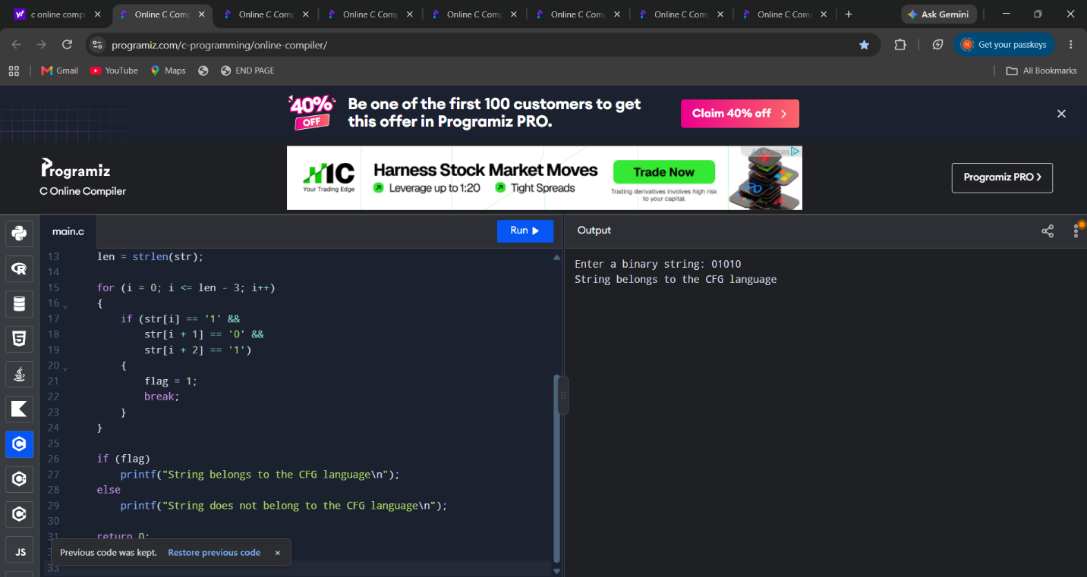
Result
The program checks whether the given binary string contains the substring 101. If it is present, the string is accepted; otherwise, it is rejected.

- 8.Aim:Write a C program to simulate a Non-Deterministic Finite Automata (NFA) for the given languagerepresenting strings that start with b and end with a
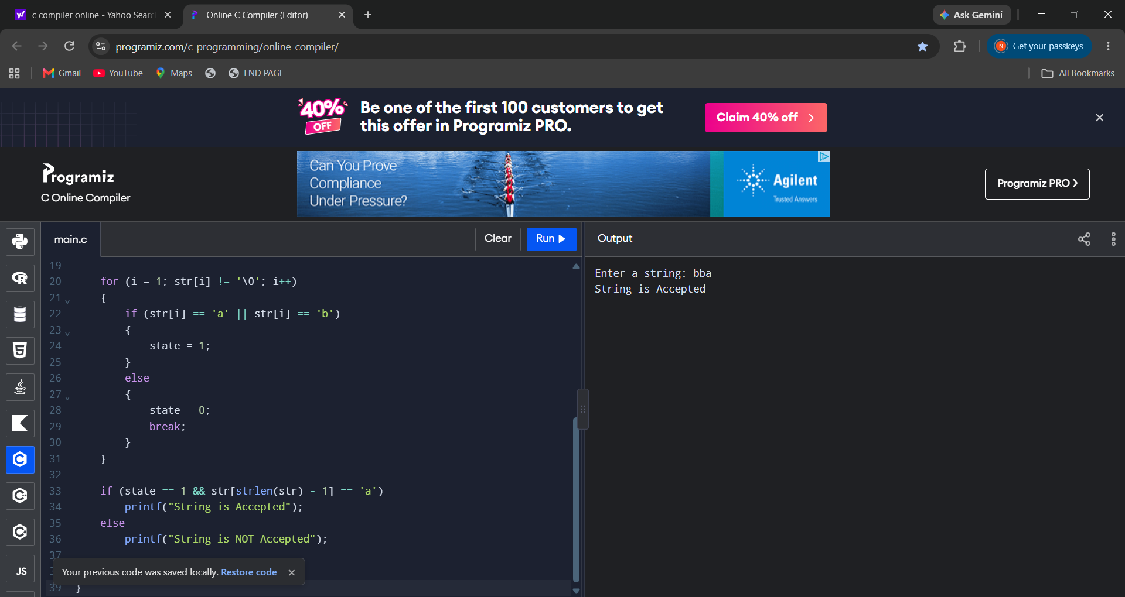
Result
Thus, the C program to simulate an NFA for strings that start with b and end with a is executed successfully.

- 9.Aim:Write a C program to simulate a Non-Deterministic Finite Automata (NFA) for the given languagerepresenting strings that start with o and end with 1

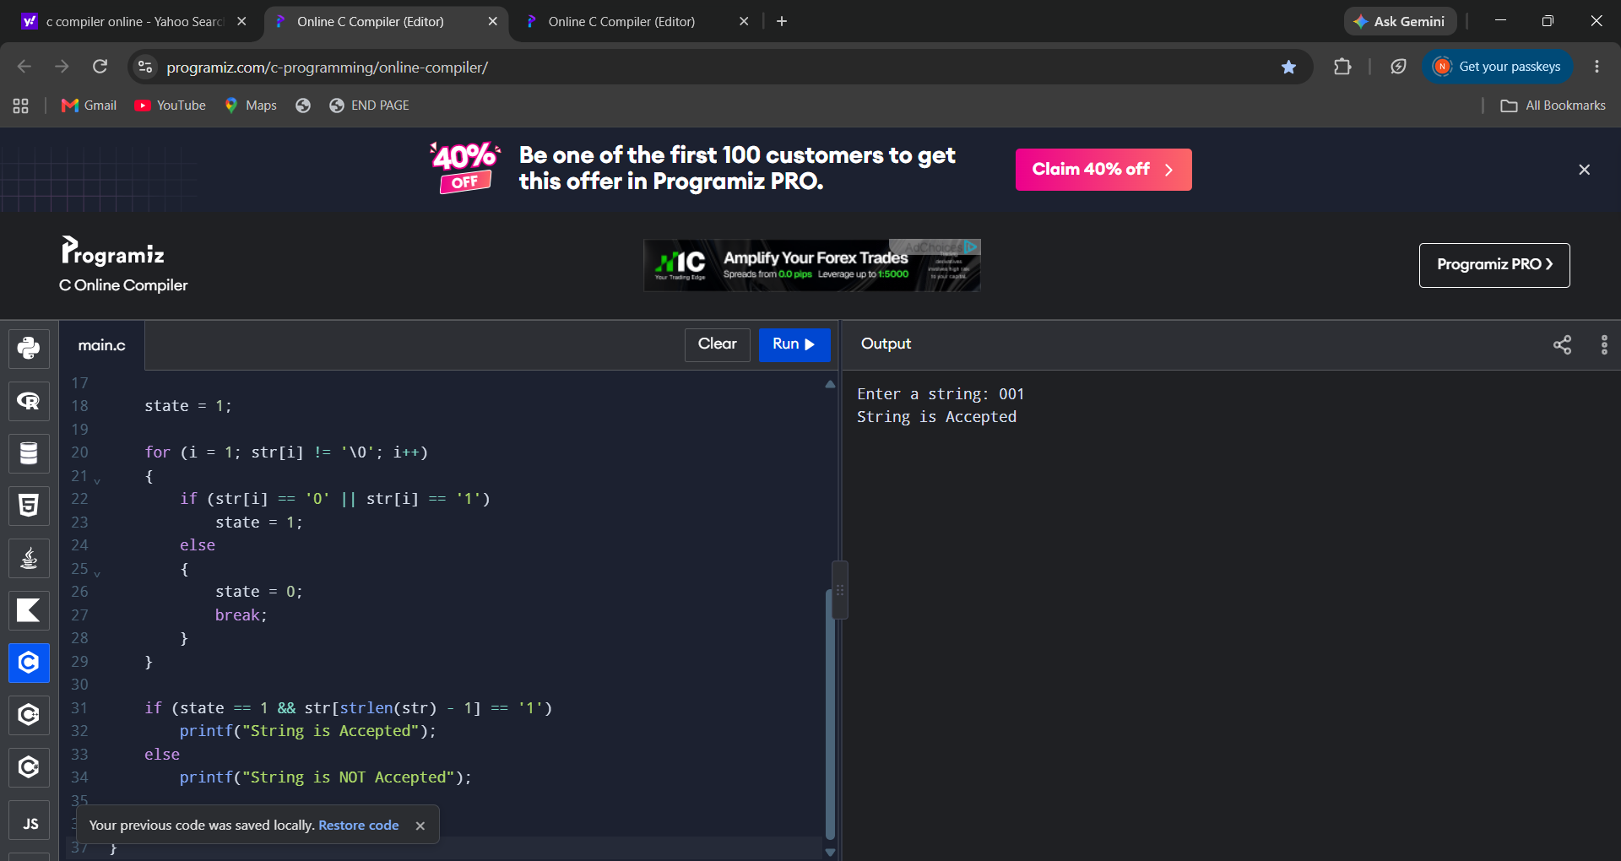

Result:Thus, the C program to simulate an NFA for strings that start with 0 and end with 1 was executed successfully.

